# Manage Tax Elections:

Step 1: From your profile click on Pay



Step 2: Click Edit on the tax elections tab

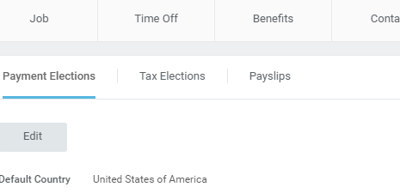

Step 3: click update

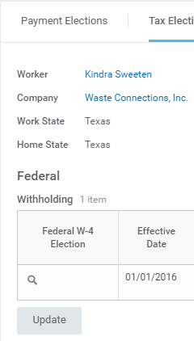

Step 4: select an effective date and click ok

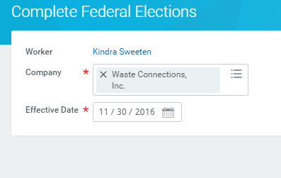

Step 5: Review tax elections, make changes and click ok